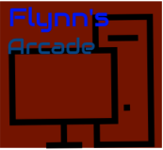

*Flynn’s Website*

*Antony’s*

*Portfolio*

Contents

***Area of Investigation:*** 2

***Design Sketch:*** 7

***Final Concept Idea:*** 8

***Design Changes:*** 9

***Evaluation:*** 10

***Bibliography:*** 11

***Design Brief***

***Flynn’s website has been slowly losing money as the trend of accessing games has moved away from social ‘video game arcades’ to at home ‘video game consoles’ such as Atari and Commadore 64. Flynn wants to reposition his business as a venue for selling new games and trading used games. Flynn wants you to design and create ‘alpha phase’ website that communicates his new business model.***

***Criteria:***

* ***Good colours***
* ***Use headlines***
* ***Provide information about the website***
* ***Provide things for the contact page (email, phone number)***
* ***Designs to match theme***
* ***Use effective and good pictures***

# ***Area of Investigation:***

***Research:***

***When researching for the designs of our website, we used many applications and websites to help design and get ideas for the website including types of fonts and pictures to use, using the websites helped the ideas and of what is needed to make a good website and how to make a good website. These application and websites allowed us to do well and really helped me on making my website better than expected.***

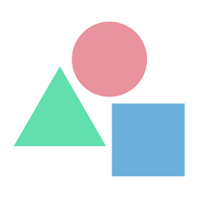***LogoMakr:***

***When I made my website, I used logomakr to make the logo, logomakr was helpful as it provided many pictures that I could use to make the website’s logo, when design the logo, it brings the user to a white canvas/screen, to which you could add shapes and pictures like a laptop, computer or more. It gives access to put text on the design. You can change the colours of the logo and the website also gives access to change the colour of the canvas to black and add grids to make designing easier. When finishing the logo, the buttons on the top right helps save and will bring you into a screen, where you can either copy the link at the bottom of the page (save link URL) or pay money to get quality saving/downloading including a ‘never get blurry’ setting so when zooming in, it will load quicker, but since we are making a logo for the websites, we just copied the link of the logo.***

***Gaming/ Online Shopping Websites:***

***We used different website to get ideas and help like JB HI-FI, we use the websites so we can get ideas for our websites and how we can make it look good, we used ideas like putting a contact page and the home page. Using websites like JB HI-FI helped see what to do to make a website look like a real website.***

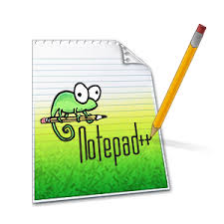

***Notepad++:***

***Using notepad++ was for the coding and design of our websites, we used the index.html, style.css and much more that helped us make the website, in notepad++, it brings you to a white screen from which you start the website designs, the application helped us but using a bit of help from other websites, the designs like making the sliders were easier.***

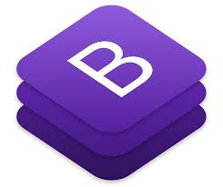***Bootstrap:***

***Bootstrap was where we got the coding that we needed to make the website, I gave a range of different ways of making a website like the sliders, and the container (changes the background colour). Bootstrap helped us with the coding as it provided already done coding. It also gave different tutorials that helped the website and has different section with subtitles so it was easy to find the ways to different type of coding (border, background colour, slider etc). Bootstrap was used for both style.css and index.html.***

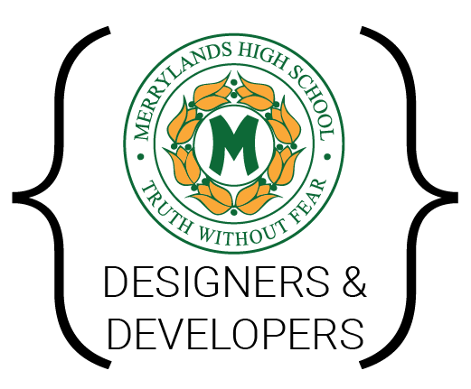***MHS-dev Design Toolkit:***

***In the MHS-Dev Design Toolkit, we were given 20 different options, one of the options that was given was the colour option, in the Flynn’s website mood board, the colour option gave us 5 options, one was the colour palette generator, the website brought us to a blue-ish screen from where it gave options on whether we want to upload a picture or try with a demo picture, I uploaded a colour and gotten the different colours from it. The colour palette generator allowed us to get the colour we were looking for and that’s how I got my colours. Other things we used are the typography, typography was where we got out fonts for the website and the image and iconography was where we got the logos of the social medias like Facebook, Instagram and twitter, with the help of the options, we were allowed to work on our websites.***

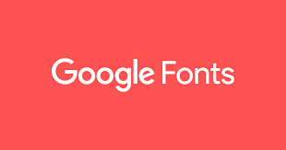***Google Fonts:***

***We used google fonts to get the fonts for the website, we had to choose from san-serif and sans, using google font was useful as it allow us to get fonts for the websites design, at first it was hard to find a font but after, looking for the font was easy for some people. Google font allowed us to find fonts that people around the world published and some are more unique than others. When you find a font you like, the font you choose will have a ‘+’ sign on it, from there it would put the coding and link to the font and the type of font it is, so roboto, is a san-serif. Used in coding for style.css changing the fonts of our website.***

***GitHub:***

***GitHub was used to save our work and be able to work on it on another device, GitHub helped us be sure we don’t lose our work and can be worked on after installing the applications needed to work on it. GitHub is useful also due to the easy access to the websites, only need to create an account and start working, committing and pushing the work is the most important part of using GitHub especially if you’re going to be working on more than one device and ta different places.***

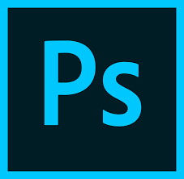***Photoshop:***

***We used adobe Photoshop to work on our sliders that we will need for the website, when we designed our websites, I came across many difficult things that changed how I had to do my design like moving an object so that it’s at a good place and changing the size of a picture to fit the website slider, making the perfect design to fit the theme was a positive but would take a lot of time to get correctly and was the part I struggled a lot in, designing the website’s slider was hard but I manage to do half of the amount I was supposed to do but I think I did okay with it.***

***About Flynn:***

***Flynn Is a character from Tron, he is known for liking neon type colours/ patterns, or liking symmetrical type objects and buildings. In Tron, everything is symmetrical or neon coloured, sometimes both. In Tron, things happen like battling to live which was what Flynn had to do, being chased down. Flynn originated from a guy named Kevin Flynn, who ran a company in California called Flynn’s Arcade.***

***Data Communication:***

***The data communication consist on 5 main components; Message, Sender, Receiver, Medium/ communication channel, Encoder and decoder. These 5 components work on sending messages from you to a website so that you can access a website, also allowing people to play online in games, designing things for a website and messaging friends and relatives about things like their experiences when going somewhere or checking up on them.***

# ***Design Sketch:***

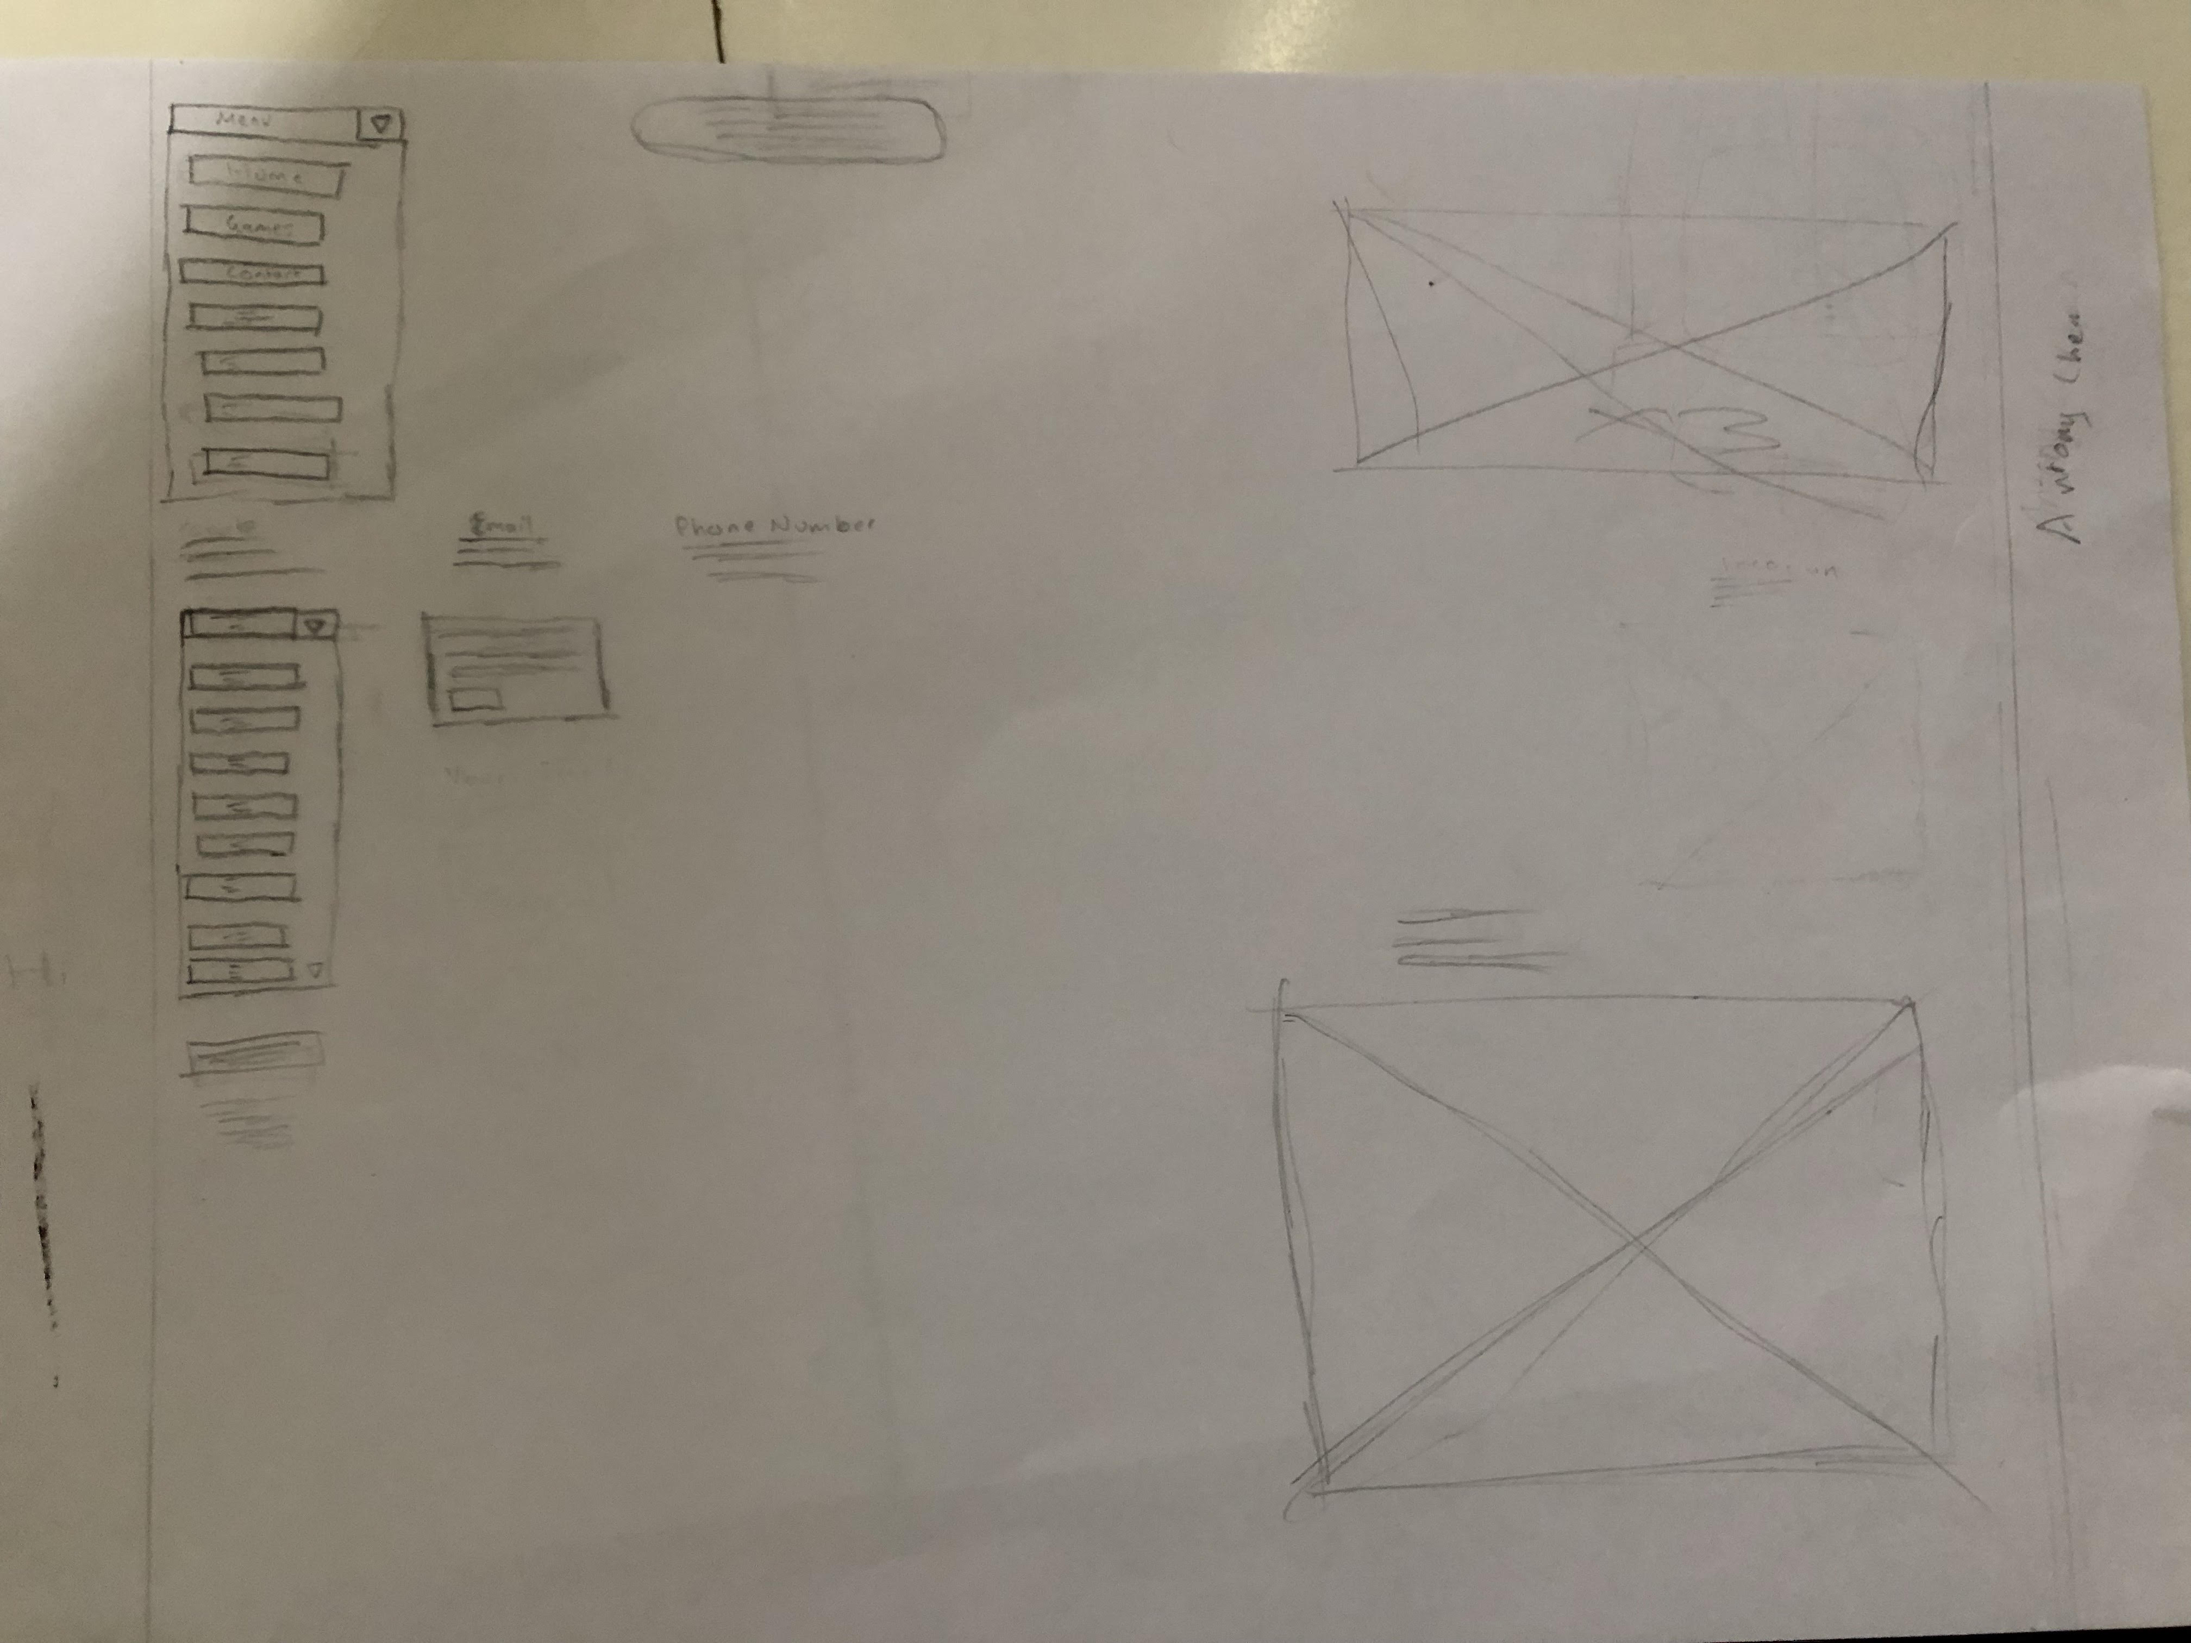

***When I was designing my website, I got help from the people around me giving me ideas and help on how I could improve my website, the help given guided me through how to do my website like the design of the slider, the logo and the mood board that was started at the start of the term. Design the website was complicated for me because I can’t draw as well as others in the class but I managed to get the design accurate and good, with the help of other people’s ideas, but eventually, I was able to get the perfect look and sketch. Getting the right design to match a website to where people can buy things took a lot of time but using help by sketching, I was able to get it right. Also taking note of the buttons like home and contact in the websites like JB HI-FI and EB Games, drawing a sketch of it was okay but helped make the design look good. When we drew the things on paper, we faced many problems like the website EB Games not working but we got around that and worked with what we got like JB HI-FI, after drawing a good sketch we had to do both for a PC and in mobile/laptop. Drawing them took a bit of time as we need to make it accurate so it fits well, like size and shape, this ‘bit or time’ benefited us as it helped us a lot.***

***At first, when I was designing the logo, I thought that the look was bad, after getting ideas from the people around me, I changed look and made the logo look better just using small changes like colour and shapes. Eventually I got the logo I wanted to get and stayed with the logo’s design. Using the ideas of the people around me helped me make my logo look better and more simple compared to my other design.***

***Using the videos set onto the bootstrap folder helped us with the coding as we were told what to do and where to go to find the coding for the websites.***

***The video showed how to design the website and where to put the coding which helped a lot especially when I finally started on the design for the website, including adding pictures and coding for other things like the sliders and logo. The videos also allowed us to check back on the work to find out if we are missing any coding and what we missed out on a previous lesson if we were ever absent from school, especially if what we missed out is really important for having a really good website design.***

# ***Final Concept Idea:***

***Colour Palette Logo***

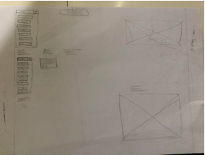

***Wire frame***

# ***Design Changes:***

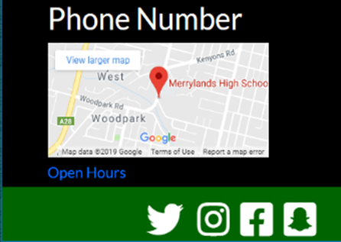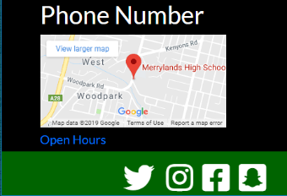***Changing my design helped change the websites appearance, at first, I thought that my changes didn’t improve much but later finding out the changes helped fit the colour palette theme, using the feedback, helped me change the designs, my first logo design was too detailed and didn’t look good compared to the current logo that I’m using right now. Adding the drop box was hard because I needed to know what I can put in it, when I did it, it turned out better than expected, I expected more mistakes like things not working or making things too big or small. Design the slider, we needed to make things for it like a folder and the amount of slides needed.***

***Also using different colours to change the font colours for my website helped for instants, using green for the social Medias and the colour blue for the open hour sign, although, I didn’t get the time to finish off the website, the changes of my design helped me with making my website look better and more detailed.***

***Using different ideas to make the contact page also linked to making the home page of my website, just a little bit more like adding the email and phone number. Designing the website was tricky at start because of all the coding that needed to be done to make it as accurate as possible but after getting it done, I thought I did well. When we got the map to load in, we needed to find the map we are putting in and then copy the link. The part that helped me the most was the use of bootstrap and the videos that were sent to us to watch. When I was designing, I made many mistakes like forgetting coding and missing a lot of the important parts.***

# ***Evaluation:***

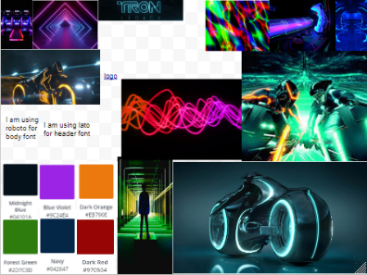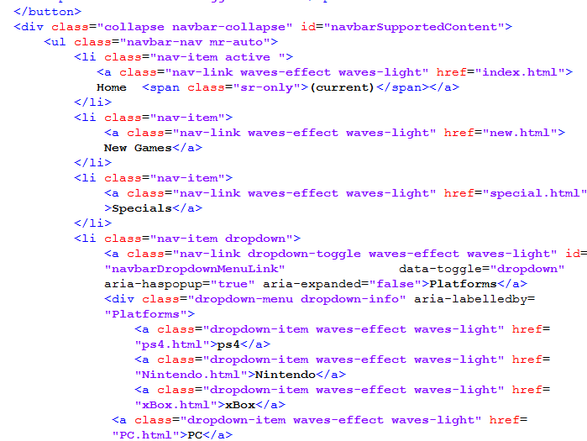***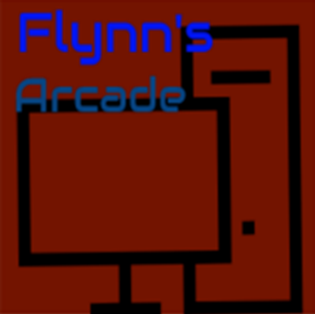When we finished designing our websites, there were some good and bad features about it, including me not being able to finish all my sliders or the products sold and method of payment. The positives of my website was that it works and that the coding I did wasn’t wasted and messed up, everything is seeable from another view like on mobile. I felt like there was more to improve on if I had more time and focused more on the task over everyone else. The main point of the website was to see what I could do and what I shown could have been better but it still looks good and I knew that what I didn’t isn’t the worse or best, taking time to design was the most important part of designing which was where I lack on because I needed more designing and rewatching the videos sent to us.***

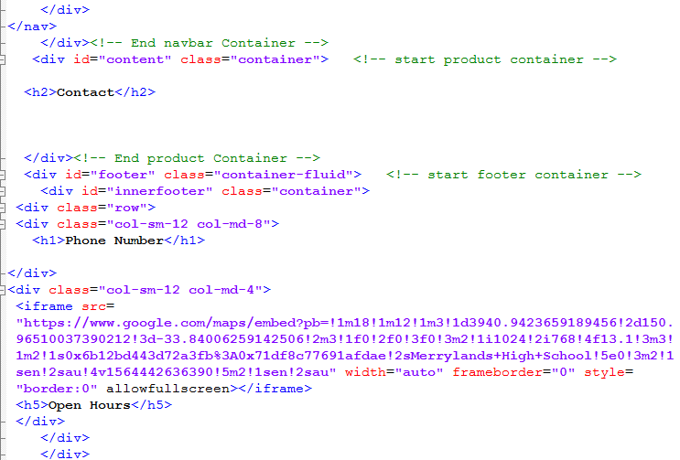***I could improve my website and design by finishing every part I missed out, change up the fonts used and the colour used but most of all, fix the contact page, I founded out that the contact page is too plain and there is not much things on it. Other things I could work on was the logo design and the mood board that we started at the start of term 2, I felt like the mood board wasn’t my best attempt on it and knew I could of done was better than that. Everything that was worked on, I knew could have been improved even win a small extent like changing colour or font and size of the website. The wireframe could have been made better if I focused more and ask for more tips on how to make it better like more shapes to make the buttons.***

# ***Bibliography:***

[***http://www.mhs-devs.com.au/designToolKit/***](%20http:/www.mhs-devs.com.au/designToolKit/)

[***https://github.com/***](https://github.com/)

[***https://getbootstrap.com/***](https://getbootstrap.com/)

[***https://fonts.google.com/***](https://fonts.google.com/)

[***https://www.jbhifi.com.au/***](https://www.jbhifi.com.au/)

[***http://tron.wikia.com/wiki/Flynn&#39;s_Arcade)***](http://tron.wikia.com/wiki/Flynn&%2339;s_Arcade))

[***https://logomakr.com/***](https://logomakr.com/)

[***https://www.ebgames.com.au/***](https://www.ebgames.com.au/)

[***https://www.google.com/maps/***](https://www.google.com/maps/@-33.8781304,151.165525,13z)

[***https://images.google.com/***](https://images.google.com/)

[***https://fontawesome.com/***](https://fontawesome.com/)

[***https://www.canva.com/colors/color-palette-generator/***](https://www.canva.com/colors/color-palette-generator/)